**STRIKERR**

**Project Proposal**

**(Team 13)**

Written By

Ben Sokol

Bud Linville

Gabe Lopez

Shuai Deng

Weston Hack

The University of Kansas

Electrical Engineering and Computer Science

October 22, 2018

Copyright © 2018 by all members of Team 13.

All rights reserved.

**Project Name**

STRIKERR

**Project Synopsis**

Turn based soccer-style game with an online marketplace for player exchanges.

**Project Description**

STRIKERR is a turn-based soccer game built with Unreal Engine. In this game, the user strategically builds and trains a soccer team to compete online against other teams. As the user progresses through the game and competes, the individual members of the team develop accordingly to their match performances in different attributes like player speed, shot speed, shot accuracy, etc. If players do not get match time or grow closer to professional sports retirement age, the player begins to lose their stats. These players can be traded across an online marketplace for game currency, and the currency can also be earned through playing matches.

STRIKERR is a fresh take on soccer and is a new interpretation of how online games could be played. As opposed to games such as FIFA or Madden with hard-set teams and predefined characters; in STRIKERR, characters get randomly generated and can be bought and sold at any moment. This increased customization allows for significantly higher levels of strategy amongst the player base.

STRIKERR will create a fun, enjoyable gaming experience for gamers of all ages.

**Project Milestones**

|  |  |  |
| --- | --- | --- |
| **Semester** | **Task** | **Estimated Completion Date** |
| Fall 2018 | Finalize project details and setup initial project using Unreal Engine | 10/05/2018 |
| Fall 2018 | Get familiar with Unreal Engine | 10/19/2018 |
| Fall 2018 | Design Application Structure (User Interface, Menu Structure, Settings, etc.) | 11/02/2018 |
| Fall 2018 | Determine project assets for gameplay (Visual, Audio, Text) | 11/17/2018 |
| Fall 2018 | Implementation of Main Menu and Settings pages (including application settings) | 12/05/2018 |
| Spring 2019 | Define player attributes | 02/10/2019 |
| Spring 2019 | Implementation of gameplay | 03/10/2019 |
| Spring 2019 | Implementation of player market | 04/01/2019 |
| Spring 2019 | Implementation of online functionality | 04/25/2019 |
| Spring 2019 | Application testing and complete documentation | 04/30/2019 |
| Spring 2019 | Add game guide | 05/01/2019 |
| Spring 2019 | Submit to distribution stores | 05/03/2019 |

**Project Budget**

|  |  |  |  |
| --- | --- | --- | --- |
| **Resource** | **Vendor** | **Date Needed By** | **Estimated Cost** |
| Unreal Engine 4 | Epic Games | N/A | If game is free: $0  If game is not free:  5% of gross revenue after the first $3,000 per product per calendar quarter |
| GitHub Public Repository | GitHub Inc. | N/A | $0 |
| App Store Developer Program | Apple, Inc. | 4/15/18 | $100 if publishing on IOS App Store |
| Google Play Developer | Google, Inc. | 4/15/18 | $25 if publishing on Google Play |
| VPS to run game online server | Digital Ocean | TBD  Will attempt to use the EECS cycle servers for development | Free OR about $5/month |
| **Total** | | | **$125 + 5/month** |

**Work Plan**

|  |  |  |  |  |  |  |  |
| --- | --- | --- | --- | --- | --- | --- | --- |
| **Team Member** | **UI** | **Assets** | **Player Generation** | **Gameplay** | **Marketplace** | **Online Functionality** | **Testing** |
| Ben Sokol | • | • | • |  |  |  | • |
| Bud Linville |  |  | • |  | • | • |  |
| Gabe Lopez | • |  |  | • | • | • |  |
| Shuai Deng | • | • |  | • |  |  |  |
| Weston Hack | • |  | • |  |  |  | • |

* While individual roles are listed above, it should be observed that this is not a hard-set separation of duties. Likely, everyone will contribute at some level to every aspect of this project.

**Gantt Charts**

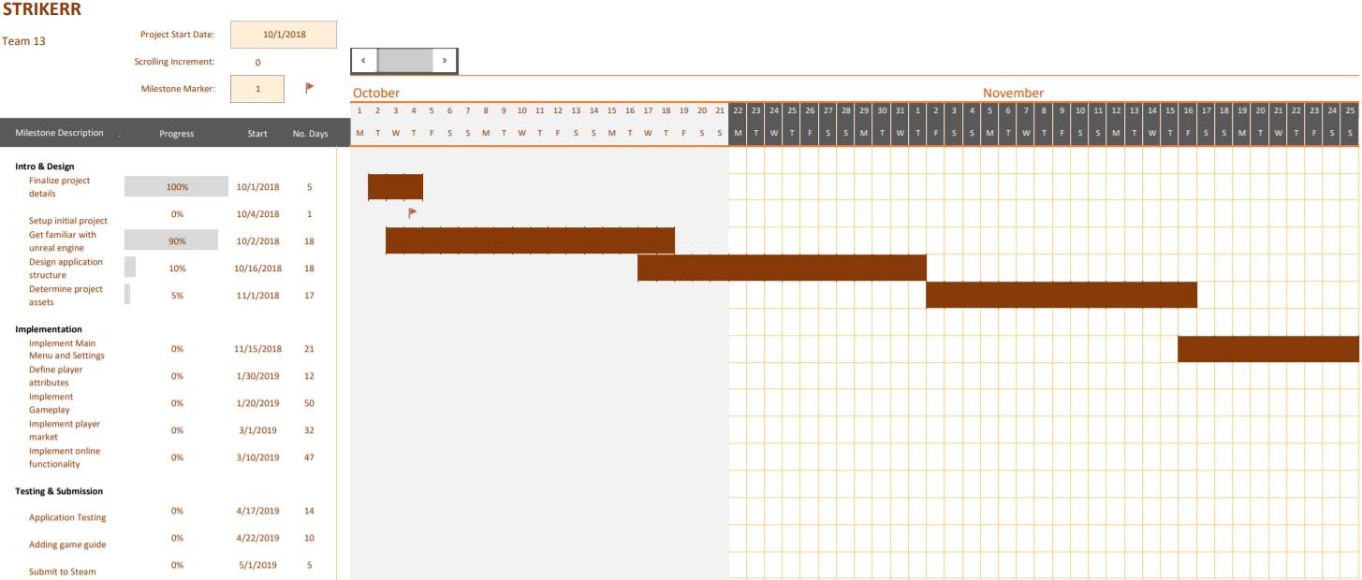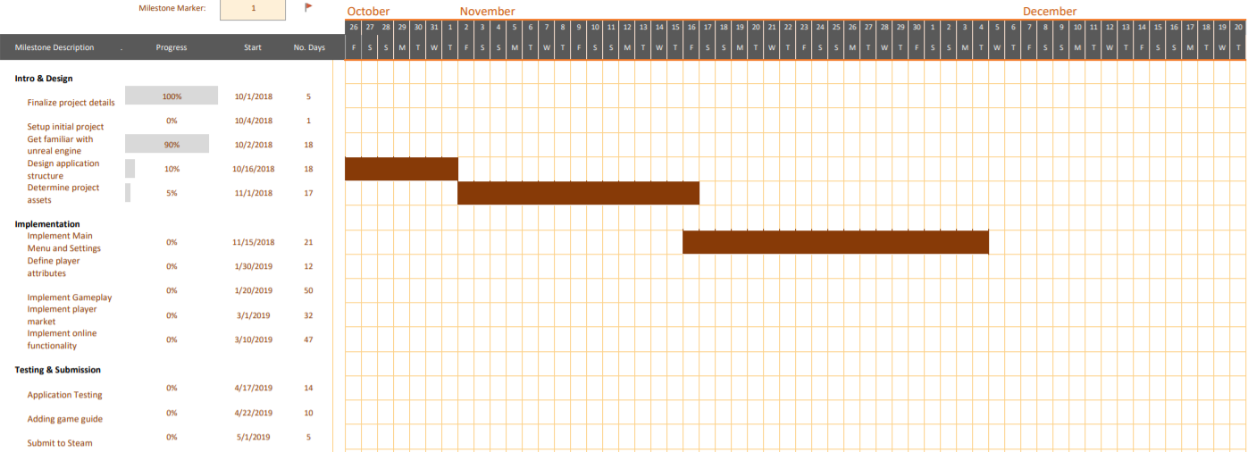

**Gantt Charts (continued)**

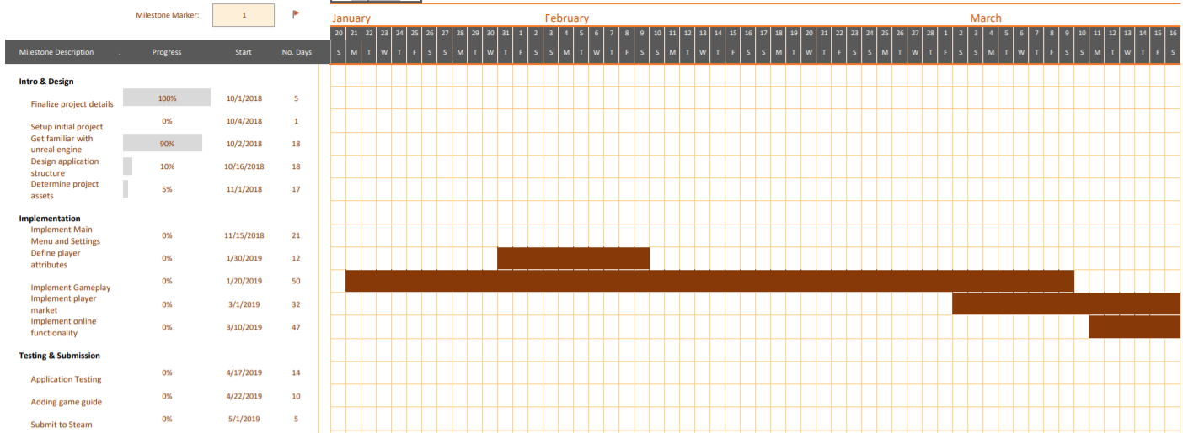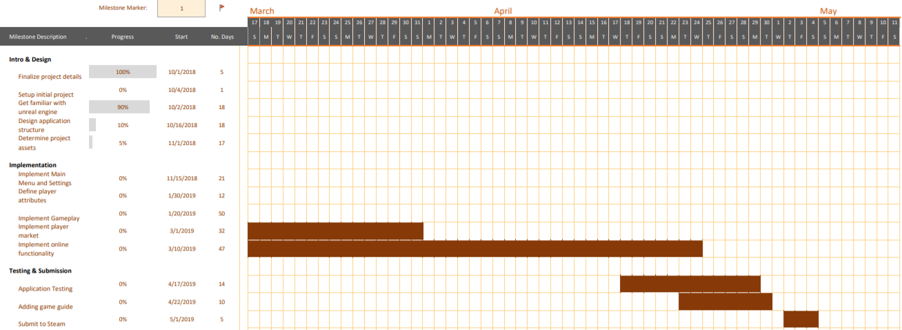

**Preliminary Project Design**

1. **How the software works**

Our software product will be an interactive, turn-based soccer game built for use on mobile devices, including both Android and iOS. We will use Unreal Engine 4, which is a game engine created by Epic Games, to develop the game, and our code will be written primarily in C++. Our game will consist of several different aspects, including actual gameplay, team management, player training, and a marketplace for buying and selling players. The game itself will be controlled by the user. For example, to pass the ball from the current player to a teammate, the user will drag his or her finger in the opposite direction of the desired target of the pass, and upon release the ball travel at a pace that is proportionate to the magnitude of the user’s finger drag. Similar actions will be used for shooting, clearing the ball, etc. When the ball is kicked, the other players on the field will make automated moves to different areas on the field.

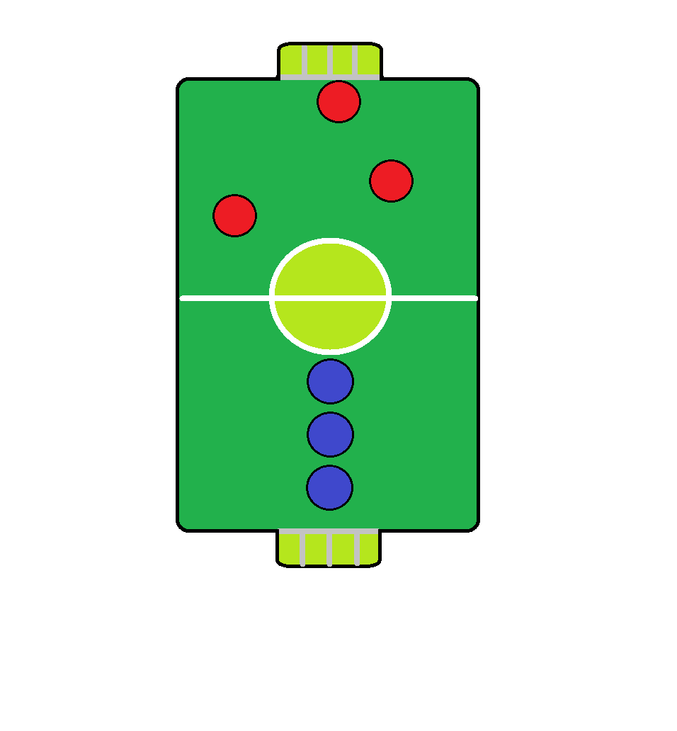

Figure 1 Randomly Generated Players

The team management aspect will be composed of things such as roster development, substitutions, player training, trades, and the purchasing of new players. We are hoping to develop an experience similar to that of fantasy football (or fantasy for any sport), in which users will be able to pick their players and manage their rosters throughout the life of their use of our game. Players will be assigned values based on their talent level and in-game performance, and these values will fluctuate over the course of a season or career based on their performance in games and the amount of training the user completes. Upon the creation of a team, the user will be awarded a set amount of some currency, although the actual currency name has not yet been decided upon (i.e. coins, dollars, diamonds, soccer balls, or something of the like). Users will be able to earn more currency by winning games, scoring goals, etc. This currency can be used to either train players, which will increase their value, or to purchase new players. This currency may also be used by the player to start games and automatically gained over time. Players will be randomly generated, and we envision that players will purchase packs of players consisting of a few different players at different positions. The training of players will be simulated, meaning that users will not actually have to manually train their players. Users will also be able to drop or sell players, and they will be compensated in the currency based on the value of the player they are releasing.

Figure 2 Overhead shot of gameplay

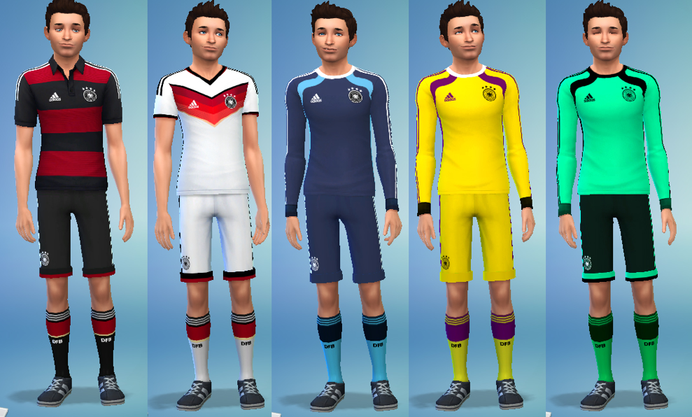

In addition to these aspects, we will also be developing an online marketplace in which users can trade their players with other users of the game. This will create a community of users that will ideally help with user retention. Similar to the experience in fantasy sports, users will be able to propose trades to other users, and at that point it will be at the discretion of the other user as to whether or not they want to accept the trade.

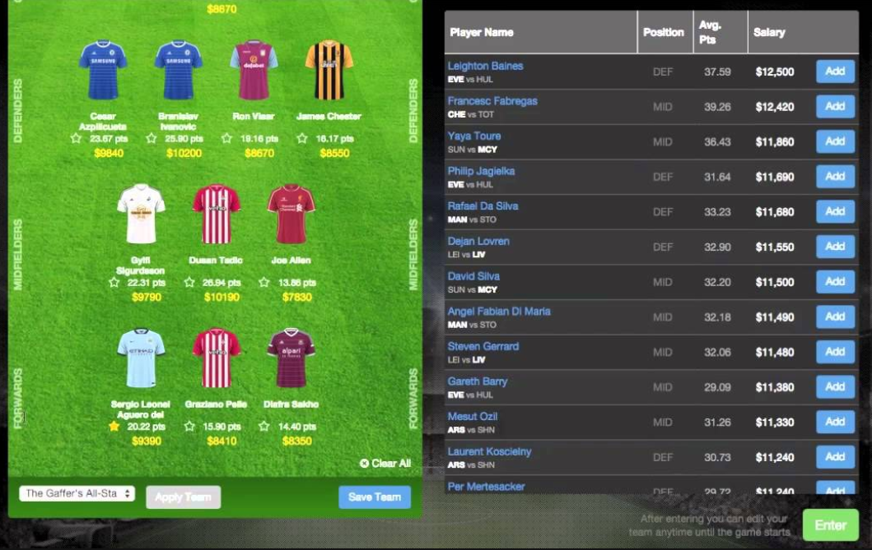

Figure 3 Sample design of market to purchase players and view your current roster

If we have time, we would also like to implement a short in-game tutorial to help new users learn how to play STRIKERR. This could consist of a slideshow showing examples, or an interactive tutorial where players can go step by step through game features. Both of these additions would be time dependent after the majority of the game has been implemented.

1. **Design Constraints**

One technical constraint we have run into is the lack of flexibility in choosing a programming language to work with. There are a number of game engines that we could have chosen to develop this game, so this was not a constraint in and of itself. However, because of its superior graphics, regular updates and improvements, large support community, and the fact that it is largely the industry standard, Unreal Engine 4 was the obvious choice. While many of the alternative game engines allow developers several different programming languages to choose from, Unreal Engine 4 mandates that developers use C++ because of its superior performance, flexibility, and power. While the choice in which game engine to use was not a constraint by itself, the obvious choice in Unreal Engine 4 has created a design constraint by mandating that we use C++ to develop the game in.

There is an additional hardware constraint associated with using Unreal Engine 4. Unreal Engine 4 does not run on older PC hardware. Therefore, for development purposes, we cannot develop on any platform older than Microsoft’s DirectX 11.

As far as business constraints are concerned, the most obvious and the most significant is the time constraint. As this project is for the University of Kansas’s senior design capstone class, we have only 8 months to complete this project. During these 8 months our time will be additionally limited by the other classes we will be taking. Therefore, there may be some design intentions that we may simply not have time to implement in version 1.0 of STRIKERR, or we may have to make compromises on some aspects of the project such as graphic quality or how complicated gameplay can be.

An additional business constraint that derives from this project being for a senior design capstone class is with regards to the team composition and makeup. If this were a project for a large gaming corporation, there would be much greater flexibility in who could work on this. Such a corporation would likely choose specialists with a lot of experience using Unreal Engine 4 and, more specifically, areas such as graphics and gameplay design. However, we are limited to the five team members that were randomly assigned to a project together, all of which started with zero Unreal Engine 4 experience.

**Ethical and Intellectual Property Issues**

1. **Ethical**

STRIKERR has two primary ethical issues: developed for all ages and the community marketplace. Ethical systems include terminology, utilitarianism, and respect for persons. All ages fulfill those three parts. For terminology, all people of all ages can play this game. For utilitarianism, people can choose their favorite players to train them, make them better. There are no respect people concerns in this project. For marketplace, there is another issue over here, which is security. Users can earn currency and use those currencies to buy or sell their players. The whole process is all through the game which is us, so the currency and the trade are safe for both side users. Another ethical concern is balancing any potential in-app purchases without making the game to centered around them.

1. **Intellectual Property**

The intellectual property issue that we need to be the most careful about is using Unreal Engine 4 as our main technology. We may use some assets developed by Epic Games (the creator for Unreal Engine 4) or other developers that have made their assets open source. Some of these assets may have various licenses associated with them. In addition, we are planning to release the game for free right now. If the game is free, we do not need to pay Epic Games. If we are going to sell the game in steam, we must pay 5% of gross revenue after the first $3,000 per product per calendar quarter to Epic Games. Additionally, depending what stores we release the game though we may need to pay developer fees. These could include Apple’s App Store, Google Play, or Steam. The other intellectual property issue is the code we write. We are using GitHub to share and upload code to provide a record of any changes to our codebase. This helps prevent any accidental changes to the codebase.

**Change Log**

The only major change to our project thus far is the platform for the game. We originally were going to develop it for PC/Mac, however we have decided to change the platform to mobile. This shouldn’t affect many details for the project because Unreal Engine 4 has built in support for IOS and Android development. The budget has changed just for app distribution, and the timeline has changed but only the distribution store or stores we will be publishing the game to.

We also make the project milestones a little more detailed (split up some milestones into separate parts), although the majority of the deadlines remain the same.